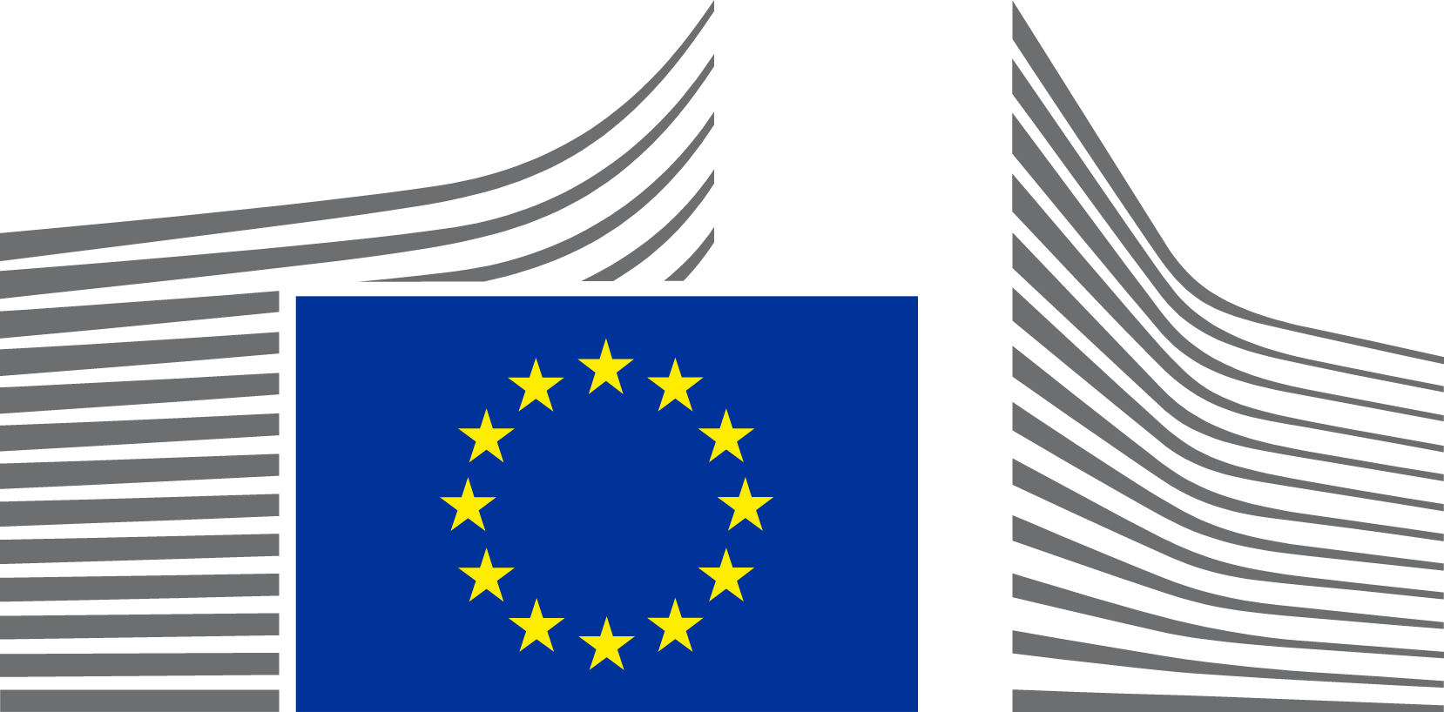 | EUROPEAN COMMISSION  Directorate-General Internal Market, Industry, Entrepreneurship  and SMEs  The Director-General

Brussels
GROW.B.1/LK
Subject: EU Questionnaire to Member States on gold-plating

Dear Madam / Sir,
As announced in the Better Regulation Council Working Party of 11 June and the EU Law Network meeting of 15 June, the Commission (DG GROW) is seeking feedback from Member States authorities through an EU Survey on “gold-plating”. The objective is to gather the necessary information to support Member States in their efforts to prevent and identify gold-plating practices in Member States. Gold-plating impacts functioning of the EU Single Market and the competitiveness of EU businesses and small and medium enterprises.

The EU Single Market Strategy adopted in May 2025, identified the “Lack of Single Market ownership by Member States: Gold-plating” as barrier no. 2 among the Terrible Ten barriers. The European Council in its conclusions of 19 March 2026 “calls on Member States to avoid gold-plating and disproportionate national requirements when transposing and implementing EU rules”. More recently, the European Council conclusions of 18 and 19 June 2026 continue calling on advancing the simplification agenda, including on gold-plating, to support competitiveness.
According to the Communication A Simpler, Clearer and Better Enforced EU Rulebook COM(2026) 380 final, gold-plating occurs “where a Member State, when transposing or implementing EU law in a given policy area, introduces a wider scope, stricter rules or obligations that go beyond the requirements set by the EU legal act. Creating more burdensome procedures than what is necessary to implement the EU law can also be considered gold-plating.”
This Communication in its chapter 4 foresees a number of actions. In particular, it indicates that “the Commission will work on a toolkit of best practices and criteria to help Member States identify and avoid gold-plating in the national transposition and implementation of EU legislation”. To prepare the Toolkit, the EU survey invites Member States to share their views on and experience in both creating and avoiding gold-plating in the single market.

- National approaches
- On the (typology of) practices commonly considered as gold-plating (e.g. in the areas of reporting obligations, registration obligations, labelling, thresholds, digitalisation, market placement, enforcement measures etc); and the processes, guidelines and institutional mechanisms set in your Member State to prevent and address gold-plating;
- Scope of the Toolkit
- On the type of elements (best practices, digital tools, “do’s & don’ts” rulebook, etc.) the future toolkit should contain to be meaningful and effective.

- Sectorial evidence
- Which Single Market areas are most affected by gold-plating, and why. Examples identified and eventually addressed including lessons learned for transposition guidance. Suggestions to measure impact of gold-plating practices.

This mapping builds on the responses provided in 2025 for the Presidency Report on national burden reduction initiatives. There is no need to replicate answers that relate to the broader scope of Better Regulation and burden reduction initiatives.

Deadline and link to the EU Survey
Please answer the EU survey available in all EU languages by 15 September 2026 via the following EU Survey link. To facilitate coordination, the questions are included in the Annex below. Please provide one answer per Member State. Note that information on the EU Survey for Member States is also circulated via the EU Law Network (Commission expert group).

EU Survey to Stakeholders
In addition, the Commission (DG GROW) is seeking feedback from Stakeholders on identified gold-plating practices and their impact and cost via a dedicated EU Survey for Stakeholders, available in all EU languages. The Survey will also be open until 15 September. We encourage you to raise awareness and circulate the link to this survey among your respective national and regional business stakeholders' networks.

For further clarifications, please contact GROW-SIMPLIFICATION@ec.europa.eu.

Kind regards,

GROW.B1 unit Planning and Simplification
Directorate General for Internal Market, Industry, Entrepreneurship and SMEs (GROW)

ANNEX: EU Survey questionnaire for Member States on Gold-Plating

Gold-plating involves exceeding EU legislation requirements or administrative practices during national law transposition and implementation, adding unnecessary complexity, costs, and burdens to stakeholders without necessarily infringing EU law (often referred to as over-implementation).

Gold-plating in Member States can take different forms, such as:
- More stringent norms (higher standards, expanded scope of application of EU act, language and safety demands, reporting obligations, additional labelling requirements, thresholds, removal of exemptions, etc);
- Administrative procedures (authorisation, notification or permitting requirements, parallel or multiple procedures at different levels (local, regional, national), new document obligations);
- Interpretative guidance (stringent or divergent legal interpretations of EU definitions);
- Enforcement measures (stringent penalties, burdensome information injuctions, frequent inspections).
- Others.

- National approach to prevention of gold-plating

- How does your Member State define / scope gold-plating? Which categories of gold-plating practices have you noticed? Note that the following options offer an initial suggestion of possible gold-plating practices, it does not aim to offer an exclusive list.
- More stringent norms: higher standards, e.g. supplementary substantive rules (on the characteristics of the product and/or service provision in question) beyond those required by an EU Act
- More stringent norms: expanded scope of application of EU legislation as transposed or implemented at national, regional or local level
- More stringent norms: stricter deadlines
- More stringent norms: additional language and safety demands
- More stringent norms: reporting obligations
- More stringent norms: additional labelling requirements
- More stringent norms: authorisation, notification, registration or permitting requirements not required by an EU Act
- More stringent norms: different thresholds (size, turnover, emissions, etc.)
- More stringent norms: removal of exemptions allowed by the EU Act
- Administrative procedures: new document obligations incl. authorisations, notifications, information requests
- Administrative procedures: parallel or multiple procedures at different levels (local, regional, national)
- Interpretative guidance: stringent or divergent legal interpretations of EU definitions;
- Enforcement measures: stricter penalties, burdensome information injunctions, frequent inspections
- Other [please explain below].
Please specify which category of gold-plating you noticed in your Member State.

- If you have conducted an analysis of reasons for gold-plating, what kind of reasons (unvoluntary, policy choice, other) do you attribute gold-plating to?

- Do you have dedicated measures or policy in place to prevent or address gold-plating at a legislative / regulatory level (e.g. dedicated “watch dog” authority, correlation tables, impact assessments, parliamentary scrutiny, stakeholder consultation)? If yes, please provide a description of this initiative and links if available.

- Do you have dedicated measures or policy in place to prevent or address gold-plating derived from administrative practice? If yes, please provide a description of this initiative and links if available.

- Are there ex-ante checks in place during the lawmaking process to flag instances where to-be-adopted act is gold-plated? If yes, please explain the mechanism.

- Are there ex-post review or transparency mechanisms (e.g., regulatory fitness checks, sunset clauses, public information on whether obligations stem from EU law or national policy choices) to assess whether gold-plating provisions remain necessary? If yes, please provide examples.

- Which institutions / teams are in charge of implementing your anti-gold-plating initiatives (e.g. independent body)? Who can we contact for more details?

- How have you measured impact, success or workability of this policy? If available, please provide indication of number of cases reviewed, number of gold-plating provisions/practices removed, estimated burden reduction, estimated costs, etc.

- Scope of the Toolkit

- What type of elements (such as identification of typology of gold-plating practices, best practices to prevent it, digital tools to detect, other) would you consider useful in the future toolkit so that it supports your efforts to prevent gold-plating?

- If the future toolkit was to include “do’s & don’ts” rulebook, what kind of principles would you like to be included in the rulebook to prevent gold-plating in the EU Single Market area?

- Sectorial evidence

- Which areas of Single Market EU acquis or EU sectoral legislation are more prone to being gold-plated in your Member State? What are the main reasons for this assessment?
- Which of the areas identified in the Single Market Strategy (COM(2025) 500 final) as part of the Terrible ten obstacles of the Single Market and discussed in the Single Market Enforcement Taskforce could in your view qualify as “gold plating” practices? If yes, which national practices have you identified within your country that could qualify as “Gold plating”? (Multi-select)
- Prior checks on qualifications;
- Protectionist measures concerning agri-food products;
- Excessive document requirements for professional qualifications;
- Restrictive measures concerning non-harmonised construction products;
- Streamlining permitting procedures for renewable energy (wind and solar) projects;
- Streamlining administrative requirements for cross-border service providers;
- Tackling IBAN discrimination
- Facilitate the opening of bank accounts
- Territorial supply constraints
- Other
Please specify which other areas identified in the Single Market Strategy have you noticed in your Member State?

- How would you estimate the impact of gold-plating on the given sector? What type of costs would be subject to quantification, e.g. in terms of compliance cost, lost business opportunities, time-to-comply or another measure / indicator? Any other type of (direct or indirect) impact?

- Are you aware of any administrative complaints or court cases in your Member State, that point to instances which could qualify as “gold-plating” practices? If yes, please provide more details.

For example, business associations highlight the following undesirable implementation practices that occur frequently at national level: 1. Extending the scope of the Directive and adding regulatory requirements beyond what is required by the Directive in question. 2. Not taking (full) advantage of any derogations. 3. Retaining national regulatory requirements that are more comprehensive than is required by the Directive in question. 4. Using implementation of a Directive as a way to introduce national regulatory requirements that actually fall outside the aim of the Directive. 5. Implementing the requirements of the Directive earlier than the date specified in the Directive. 6. Applying stricter sanctions or other enforcement mechanisms than are necessary to implement the legislation correctly.

