Information Enterprise / Organisation / Service

Full Name

Postal address |  | Post Code
Work Telephone |  | Work Fax Εργασίας
Website |  | E-mail
Legal Entity | Ltd ☐ Partnership ☐  Other
Award Category | Primary Sector ☐ Manufacturing Sector ☐  Services Sector ☐ *Social Innovation ☐
Description
of Activity

Number of Employees

*Social Innovation defines the Innovation which refers to social issues and values such as: environment, social inclusion of vulnerable groups, assistance to social groups, health, education as well as the development and maintenance of healthy and fair working environment.
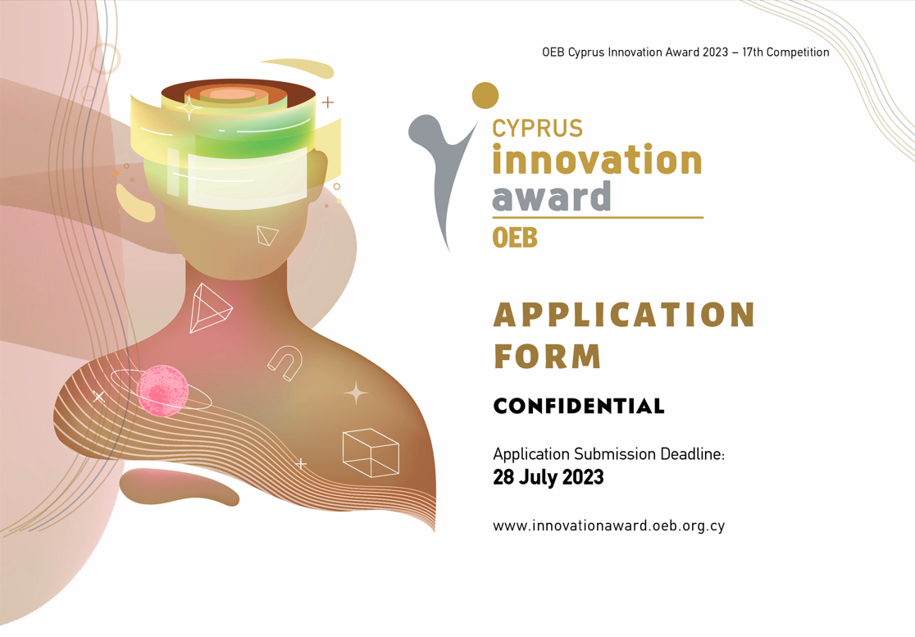

- Brief description of the enterprise / organization / service and the type of economic activity (up to 50 words)

- What is the innovation for which you are applying?
• description of the innovation
• need / purpose which led to the creation of this idea
• thoughts behind the approach / development of the innovation (up to 300 words)

- (a) Financial data of the enterprise / organization

 | 2021 | 2022 | 2023 (forecast)
Turnover
Profitability
Increase in sales %
Other (e.g. market share, service time, etc)
Note: Turnover, profitability and increase in sales for the previous years should be based on audited accounts of the enterprise. For the current year, preliminary data (forecast) are required.

(b) Information on the volume of work performed

Specify (e.g. number of files / cases / services / service time, etc) | 2021 | 2022 | 2023 (forecast)
- Social Innovation applicants are not required to fill-in part 3(a). However they should provide alternative data in part 3(b).
- Parts 3(a) and 3(b) may be completed either alternatively or both, depending on the case. The purpose is to present / document improvement in results / performance.

- Has your innovation been implemented for the first time in Cyprus?
Why do you believe it is innovation? (up to 100 words)

- When have you implemented your innovation and which improvements have been made? (up to 100 words)

- How is innovation cultivated within the organization by the management and how is the staff involved in this process? (up to 200 words)

- Has the implementation of innovation contributed to the improvement of the environment (working or natural)? E.g. Working conditions, Environmental protection (pollution, waste, etc.), Energy consumption, etc. (up to 50 words)

- What are the effects of your innovation on people (society or staff)? E.g. safety, health, wellness, equality, justice, social benefits, social inclusion of vulnerable groups, etc. (If applicable) (up to 200 words)

- What effects did the implementation of innovation have over the last 12 months?
(up to 100 words)

List data that support your position
• For Award applications in Primary / Manufacturing / Services sectors:
E.g. sales improvement, revenue, profitability, market share, number of services, reduced service time, etc.
• For Award applications in Social Innovation:
E.g. revenue improvement, volume of services, number of files, service time, benefit to the economy / society, etc.

- List below the reasons why you believe that you should be awarded the OEB Cyprus Innovation Award. (up to 250 words)

DECLARATION

- The above information is real and we are at your disposal to provide additional data, information, presentations / demonstrations and / or interview related to this competition.

- The enterprise / organization / service we represent applies and operates on the basis of all existing laws and regulations of the Republic of Cyprus.

- In case we are selected as winners of the competition, we allow the Cyprus Employers & Industrialists Federation (OEB) to keep a record of the present application form, while in case we are not selected as winners our data shall be destroyed within three months after the awards ceremony.

- In case we are selected as winners of the competition, we allow the Cyprus Employers & Industrialists Federation (OEB) to disclose our details and relevant photos / videos for the purpose of promoting the competition to the media (television, newspapers, magazines, websites, etc.) as well as OEB's media (website, social media, press releases, newsletter, etc.). I confirm that the above complies with the European Personal Data Protection Regulation.

- I understand that I have the right to request the deletion of my data at any time by sending my request in writing to the email info@oeb.org.cy or fax 22665102.

Enterprise / Organization / Service:

Name: |  | Title:
Signature: |  | Date:

Accompanying Attachments
Please list below any accompanying attachments
(e.g. brochures, product samples, USB, CD, DVD, etc.).

The application must be sent completed and signed to the following address:

CYPRUS INNOVATION AWARD
Cyprus Employers and Industrialists Federation (OEB)
P.O. Box 21657
1511 Nicosia

