CHRISTOS MICHAELIDES

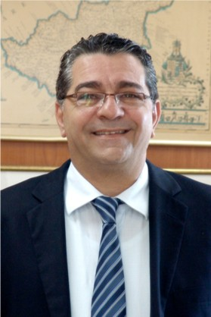
Christos Michaelides was born in Limassol in 1959, he is married and father of three children. He studied at the Erlangen/ Nurenberg University in Germany Business Administration (M.B.A.), with specialization in marketing and operational research. With the completion of his studies, he worked in the Marketing and New Product Development Department of multi-national Uni Lever. Returning to Cyprus in 1987 Christos worked as CEO for Cyproservus, a Management company dealing with the offshore companies. He subsequently founded Cypronetwork that gradually is developed in the Cypronetwork Group of Companies providing services in the fields of Market Research and Consulting in Cyprus, Greece and the Middle East.

He was a Co-founder and General Secretary of the Association of International Business Activities, Member of the Board of the Cyprus Ports Authority, Special Advisor to the Greek Foreign Trade Promotion Agency and President of the Cyprus Opinion Poll Enterprises Association.

He is the President of the Cyprus Management Consultants Association, Vice President and Member of the Executive Committee of the Industrialist and Employers Federation, Vice President of the Cyprus-Greek Business Association, President of the Energy Committee of the Industrialist and Employers Federation, Member of the Board of Cyprus Opinion Poll Enterprises Association, Honorary Member of the International Business Association (CIBA), and member of the CEO Assembly and Boards of the multinational networks Scholz & Friends (Communication) and Horwath HTL (Hotel, Tourism & Leisure).

He is a Certified Management Consultant of IMCA and has over 25 years experience in the fields of Management and Marketing, Consulting, Market Research, Communication, Strategic Planning and Operations with extensive experience in Hotel, Tourism and Leisure, Trade, Industry, Energy and Foreign Direct Investments.

